ENQUIRY WORKSHOP

Develop a file enquiry to list last five entries for a given account. Layout of the enquiry is as below

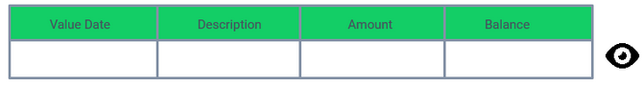

Balance – Running working balance and formatted based on account currency

Drilldown – To view the STMT entry details

Header – Add Account number, short title and currency

* Develop a nofile enquiry to display the details of accounts for a given customer. Layout of the enquiry is as below

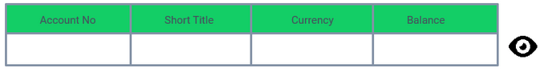

Balance – Working balance and formatted based on account currency

Drilldown – To view the Account details

Header – Add Customer no and short name

Solution for FILE Enquiry

Step 1 : Create Enquiry using ENQUIRY, I <enquiry_name>

But leave build routine AND conversion routine field blank.

P.S : we will add build routine and conversion routine later

P.P.S : <https://github.com/shekhu95/EDS/tree/master/shashank/Enquiry%20Wkshp>

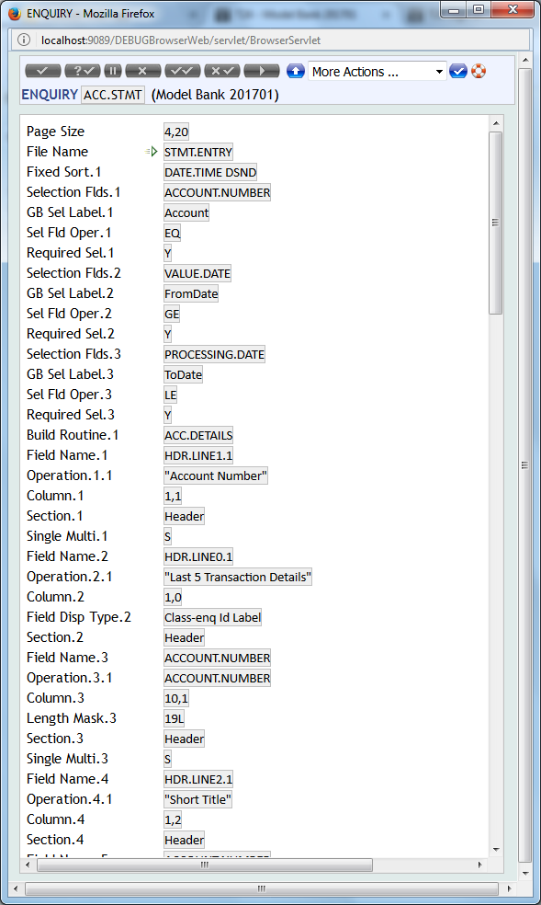

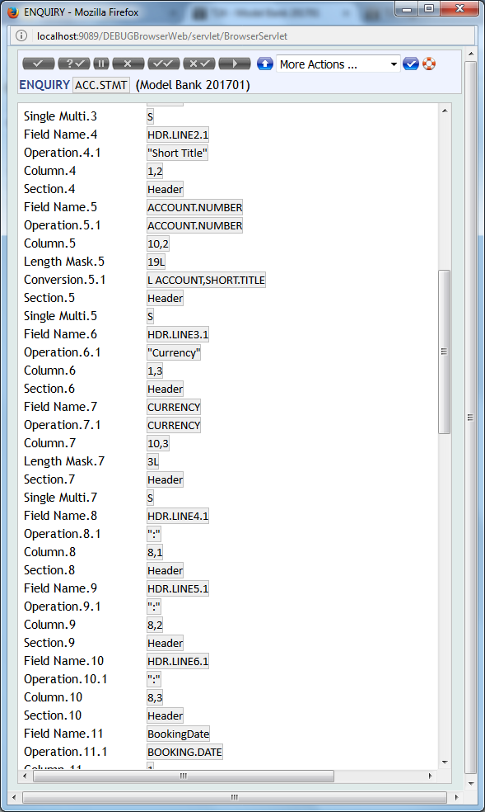

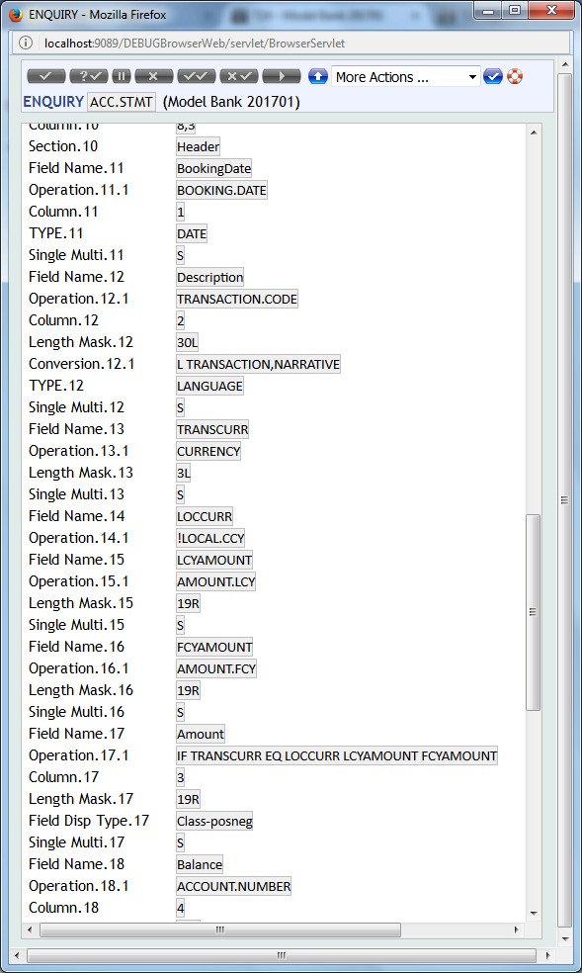

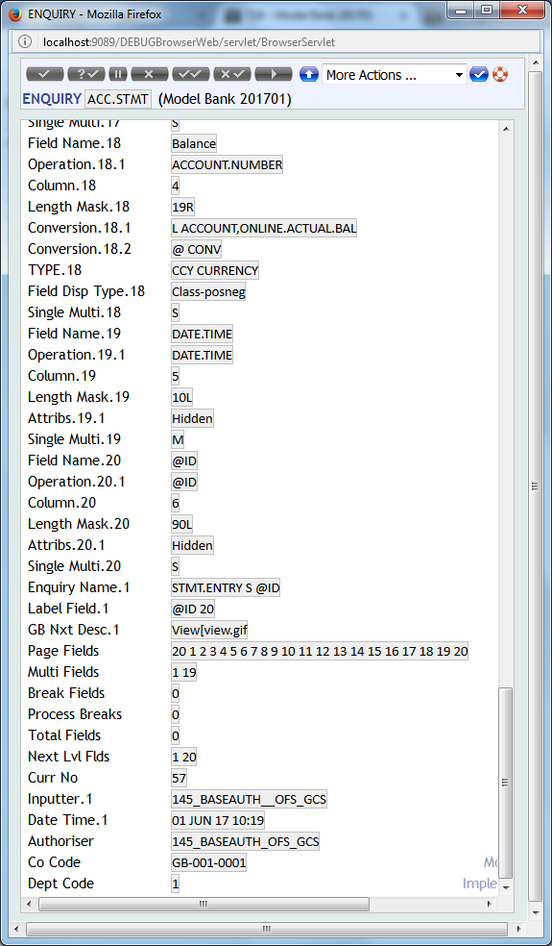

Step 2 : create build routine

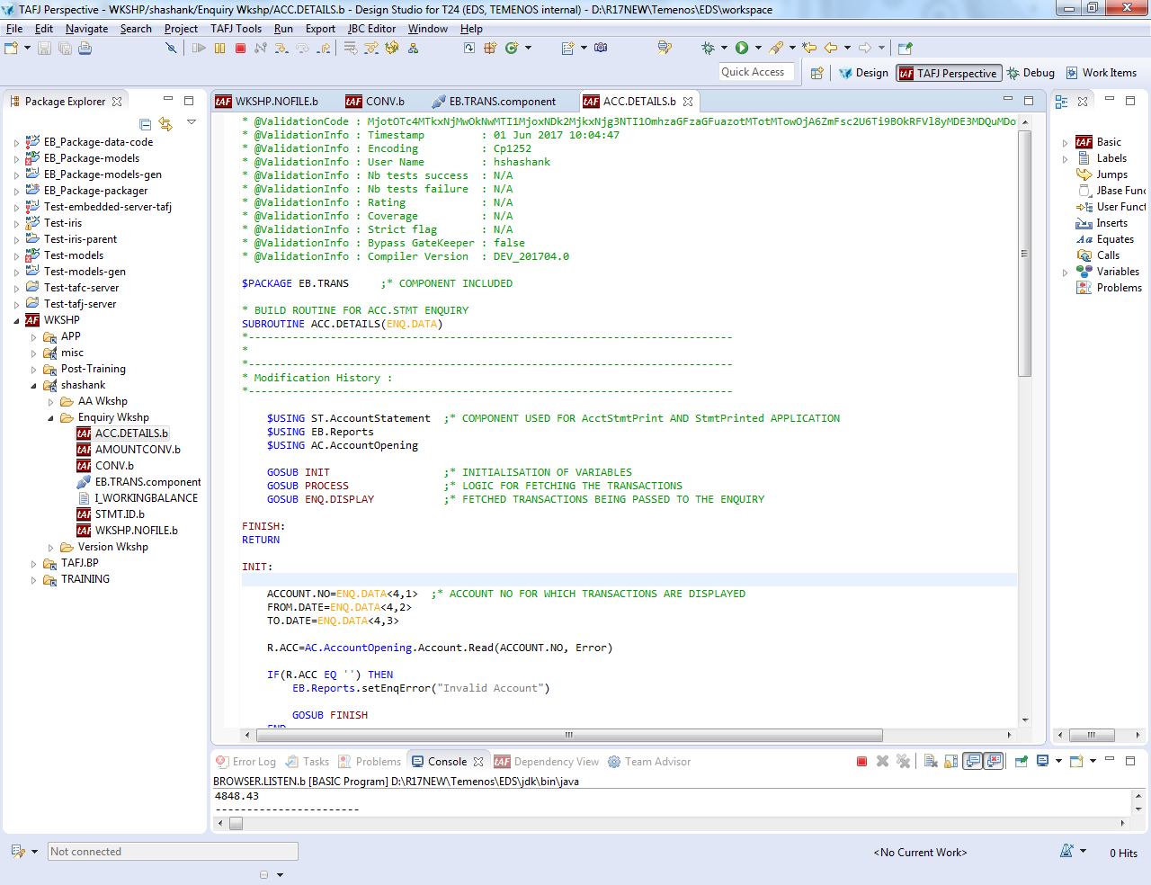

Step 3: create conversion routine

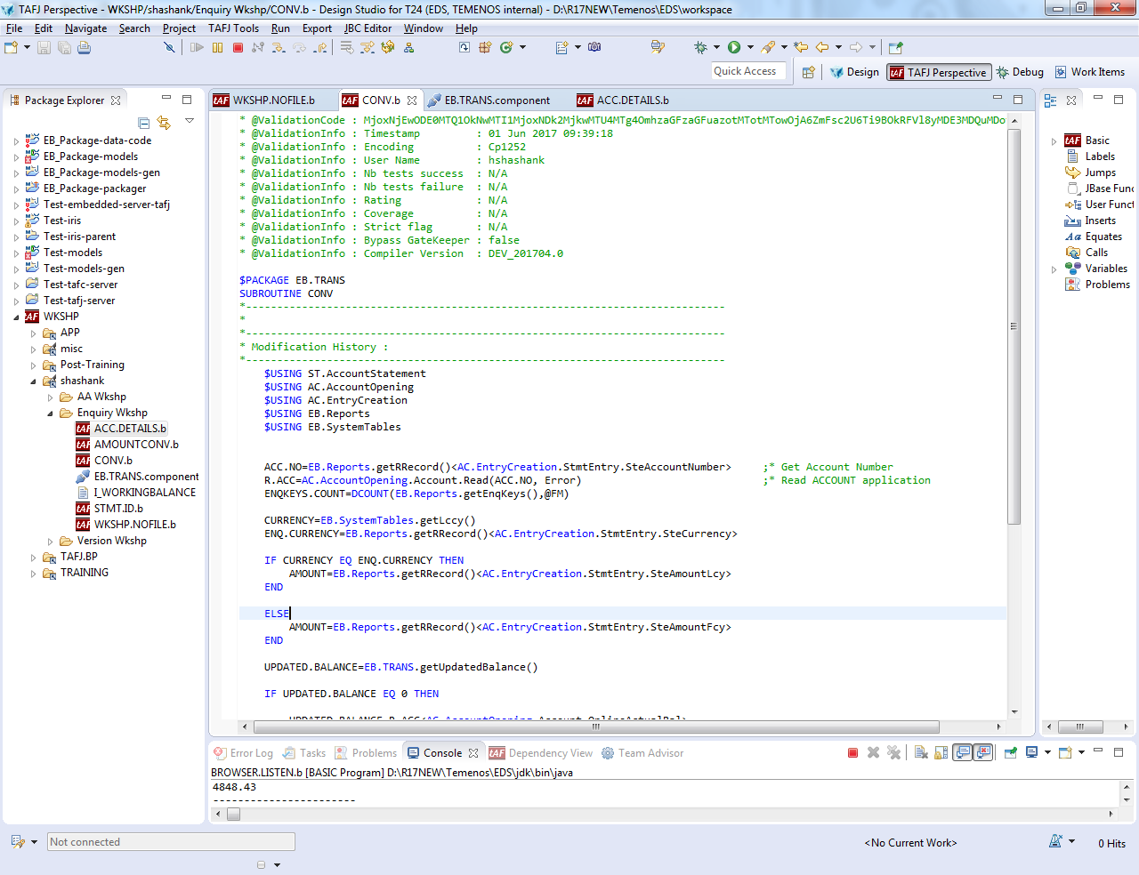

Step 4: Create a component and include these routines in that component if doing component coding

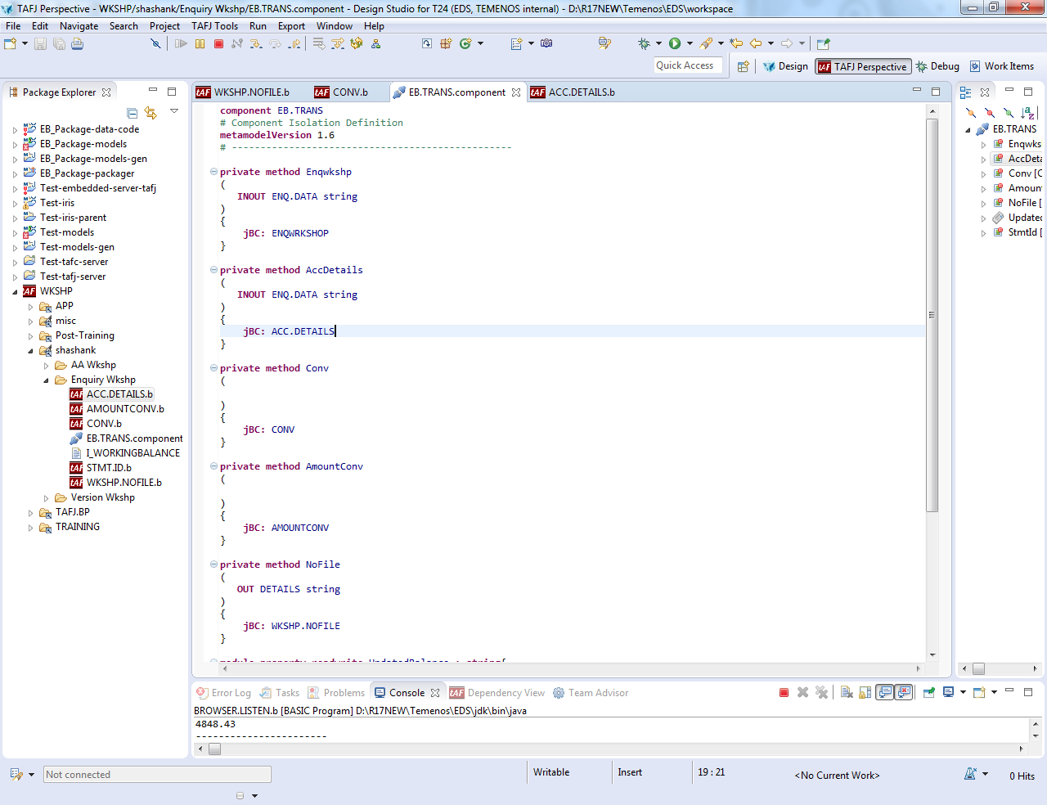

Step 5: include build and conversion routine in enquiry

Step 6: Launch the enquiry using ENQ <enquiry_name>

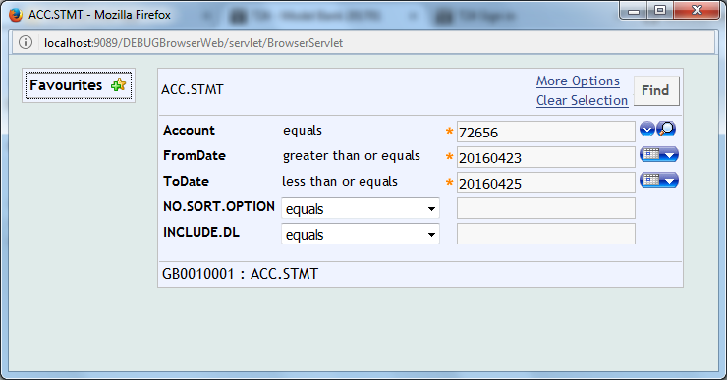

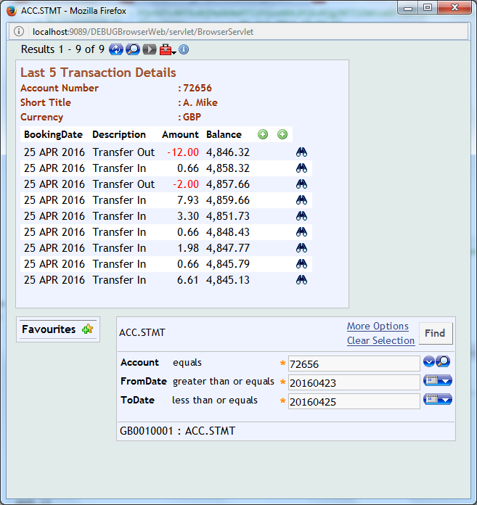

Click on the binocular button for details of the transaction using drilldown enquiry

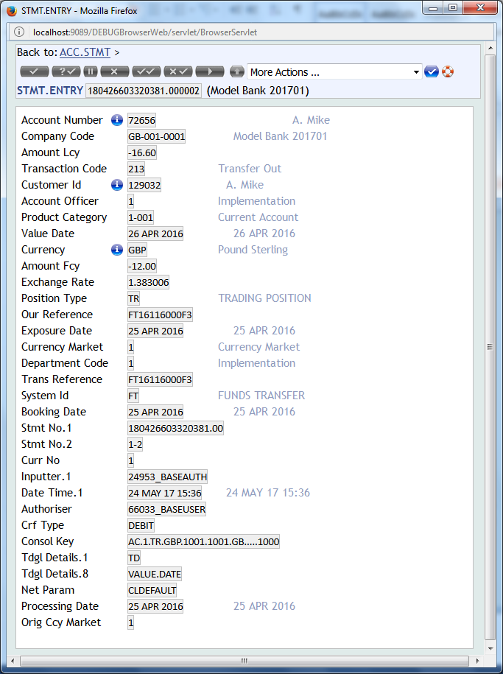

**Solution for NOFILE enquiry**

Step 1: Create the NOFILE routine and include it in a component if done using componentisation

Step 2: Create a record in STANDARD.SELECTION with ID as NOFILE.<some_name>

Give the name of the routine here

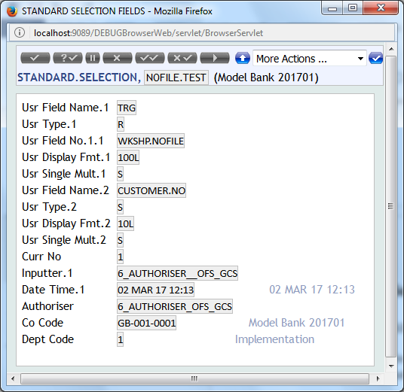

Step 3: Create the Enquiry

Give the name of STANDARD.SELECTION record as FILE.NAME in the enquiry

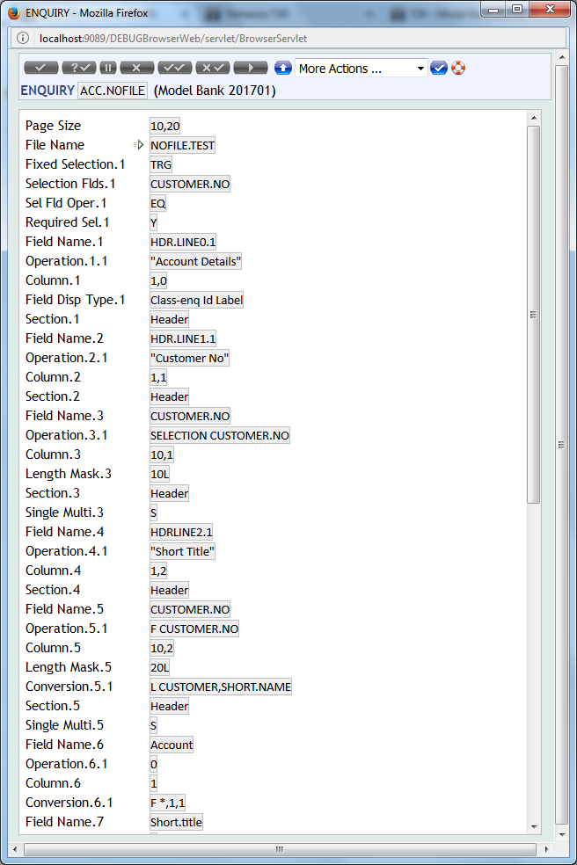

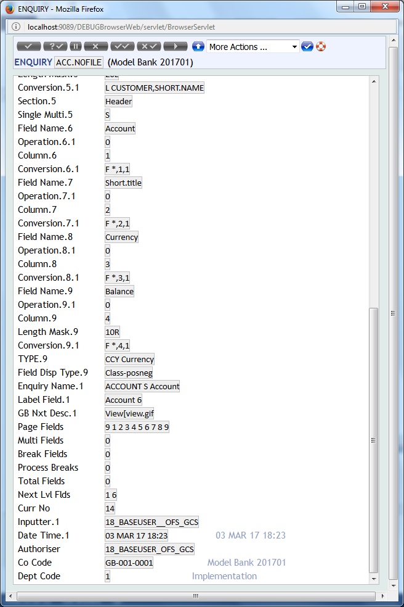

Step 4: Launch the enquiry

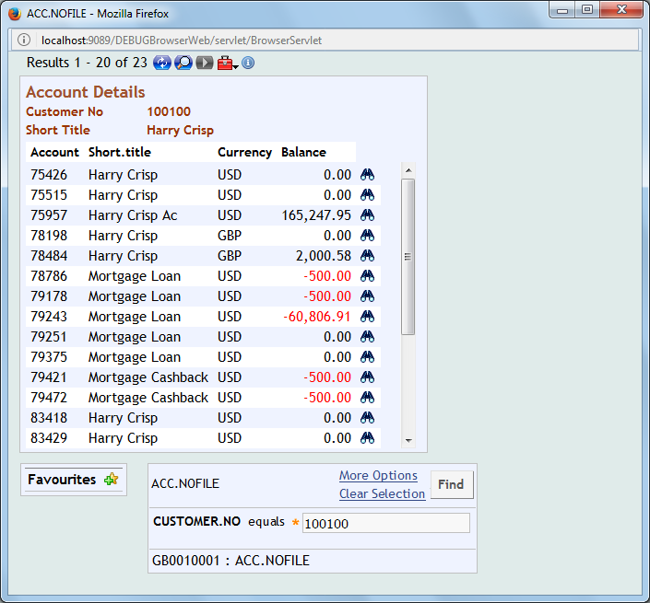

Click on the binocular button to see account details using drilldoqn enquiry

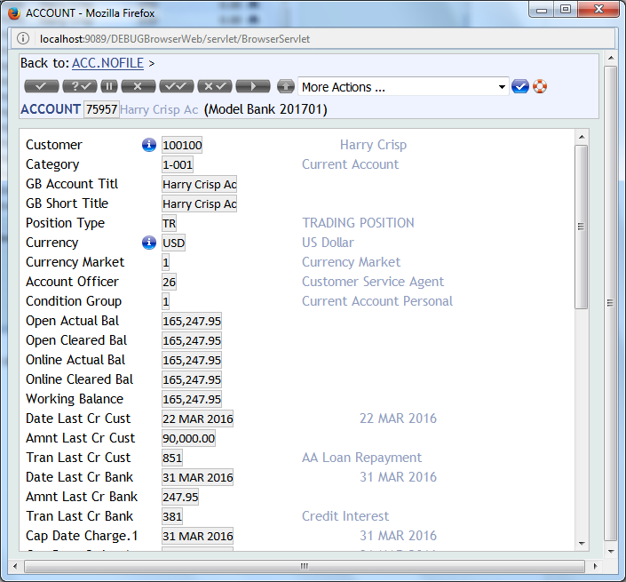



Now Start Again